 | RS485 Sensor Interface Board Kit Instructions

Date: | 26/8/2026 | Version: | 1.0 | By: | Matt Little

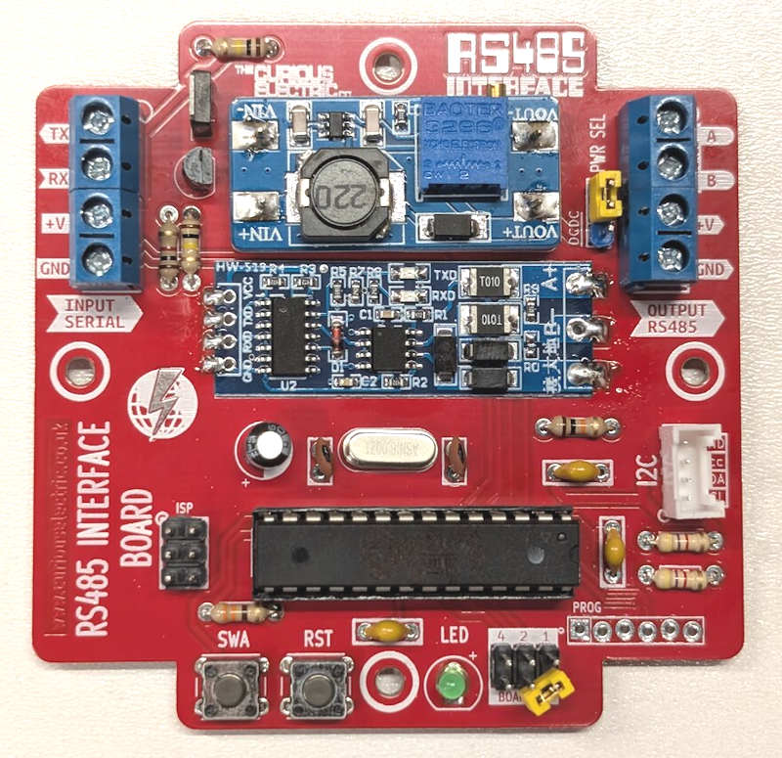 | This circuit adds an RS485 interface to an ATMEGA328 to connect to different RS485 sensors and provide averaged data via a UART interface. It is designed to be easy to use, provide correct voltage levels and be energy efficient.  Note: It requires another micro-controller unit to request and store the data from the sensor interface board.  You must upload the correct firmware for your sensor, please check the github for examples:  https://github.com/curiouselectric/SensorInterfaceBoard  It provides a more easy to use UART serial interface to obtain averaged data the sensor. Data can be 1s,10s, 1min, 10min and 1hr averaged data along with the maximum and minimum values within that time period.  It also provides a controlled step-up converter (if needed) to power the attached sensor, which can step up the supply voltage (3.3V or 5V DC) to the voltage required by the sensor, such as 12V or 24V. This can be switched off between sensor reads to save energy from the battery.  There is also an I2C interface to add additional sensors, such as a temperature or humidity.

Parts included:
 | 1 x Grove socket | 2 x 2 way headers  1 x 3 way header | 2 x 3x2 Header Pins |  | 2 x Jumpers |  | IFRF9220
 | 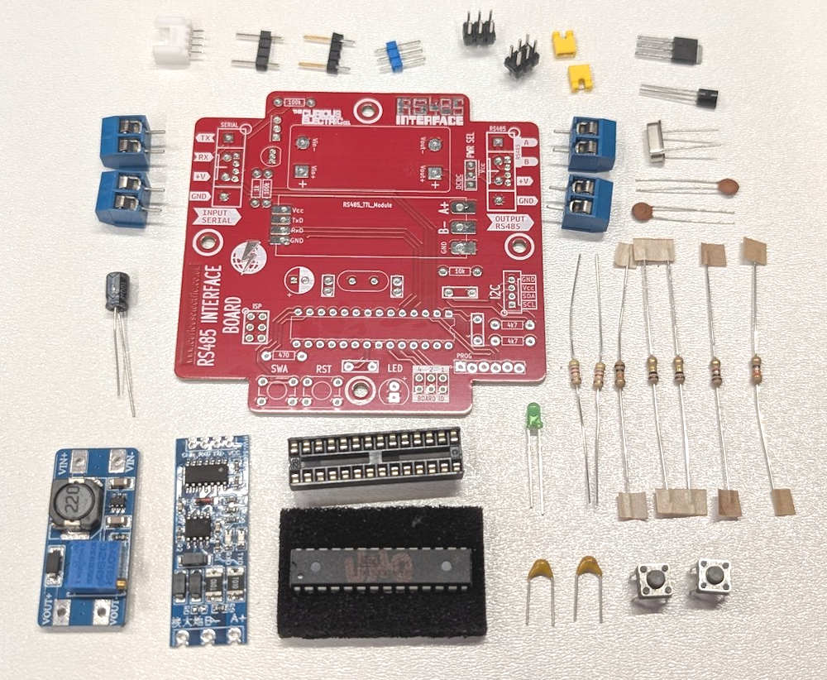 |  |  |  |  |  | IFRF9220
 |  |  |  |  |  |  | 2N3904
 |  |  |  |  |  |  | 16MHz crystal
2 x 2 way screw terminals |  |  |  |  |  |  | 2 x 2 way screw terminals
2 x 2 way screw terminals |  |  |  |  |  |  | 2 x 22pf Capacitor
100uf Capacitor
PCB |  |  |  |  |  |  | 7 x Resistors
DC-DC Converter | RS485-TTL Module | ATMEGA328 and IC holder |  | 3 x 100nf Capacitor  (2 shown!) |  | LED | 2 x Switches

Parts list:
Item | Ref | Quantity | Item | Ref | Quantity
PCB |  | 1 | Resistor - 1k | R1 | 1
Capacitor – 100nf | C1, C3, C4 | 3 | Resistor - 100k | R2, R3 | 2
Capacitor – 100uf | C2 | 1 | Resistor - 470 | R4 | 1
Capacitor – 22pf | C5, C6 | 2 | Resistor - 10k | R5 | 1
Green LED | D1 | 1 | Resistor - 4k7 | R6, R7 | 2
DC-DC Converter | DCDC1 | 1 | Tactile switch | SW1, SW2 | 2
3 Way Header | J1 | 1 | RS485 – TTL Module | U1 | 1
Grove connector 4 pin | P5 | 1 | Modified 4 way headers with 2 pins | For U1 | 2
2 Way Screw Connector  (2 for each) | P1, P6 | 4 | 28 Pin IC DIP Holder | U2 | 1
3x2 Header | P7, P9 | 2 | ATMEGA328P 28pin | For U2 | 1
Transistor – NPN, 2N3904 | Q1 | 1 | 16MHz Crystal | Y1 | 1
Transistor – N-FET, IFRF9220 | Q2 | 1 | Jumpers |  | 2

Tools required (not supplied):
 | 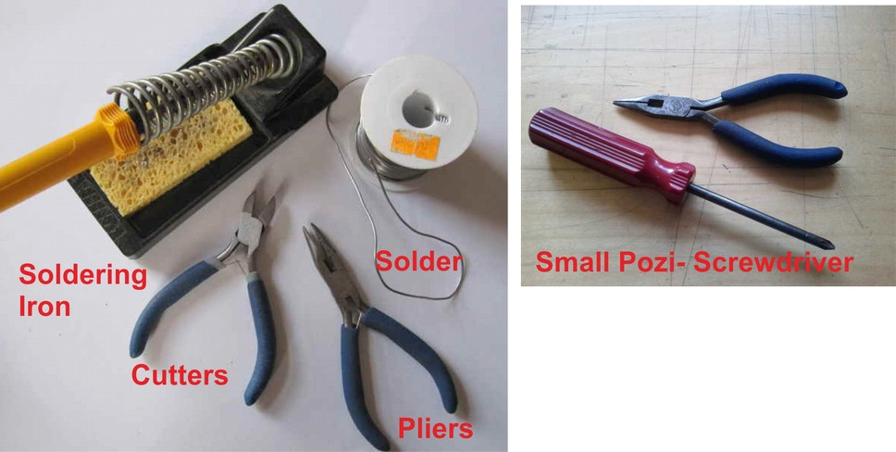
Long-nosed
Pliers
Soldering Iron |  | Posi-drive and flat-head  Screwdriver
Solder
Side cutters
Additional Items
- USB to 6 way ‘FTDI’ style serial converter:
  - Search for “FT232RL USB to TTL Mini USB Port FTDI Serial Adapter Module for Arduino 5V/3.3V” on eBay
  - Or this FTDI 3.3V one: https://ftdichip.com/products/ttl-232r-3v3/
  - Or this FTDI 5V one: https://ftdichip.com/products/ttl-232r-5v/
  - You can also use an Arduino as a USB to serial converter.
- To update/change code:
  - Computer with Arduino IDE and additional libraries installed. (See github repository for the Sensor Interface Software for more details: https://github.com/curiouselectric/SensorInterfaceFirmware ).

Device & Wiring Overview:
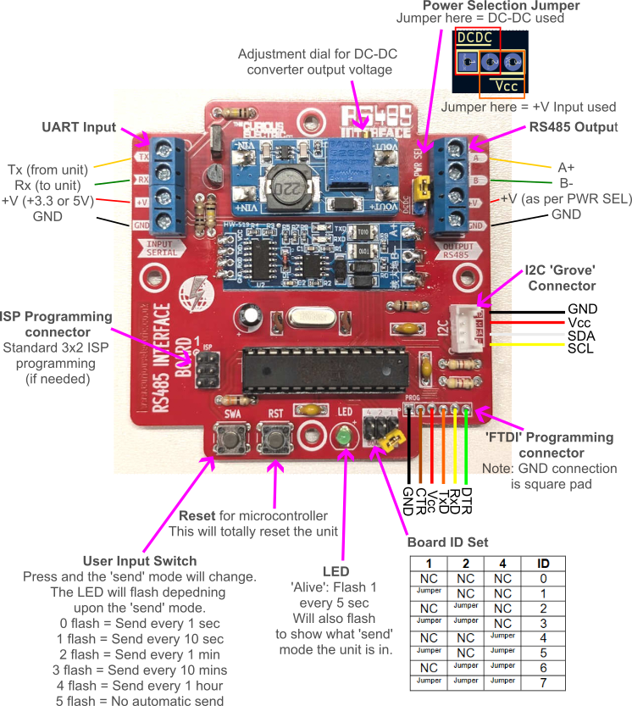
Instructions:
Step: 1 | Add resistors
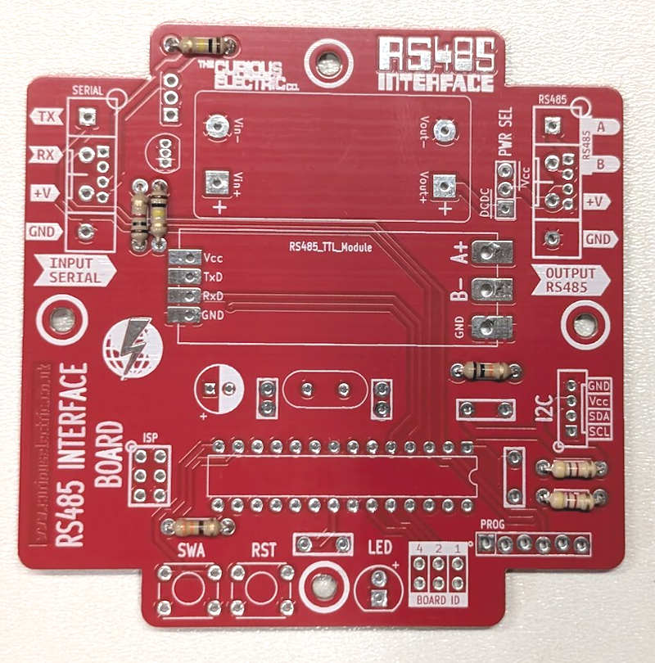 |  | Insert and solder the resistors.  Polarity does not matter for resistors.  Ensure they are soldered flat close to the PCB.  Use a multimeter or colour code chart to ensure correct resistor values.
  Value | Ref | Colour
  1k | R1 | Brown, Black, Red, Gold
  100k | R2, R3 | Brown, Black, Yellow, Gold
  470 | R4 | Yellow, Violet, Brown, Gold
  10k | R5 | Brown, Black, Orange, Gold
  4k7 | R6, R7 | Yellow, Violet, Red, Gold

Step: 2 | Add capacitors
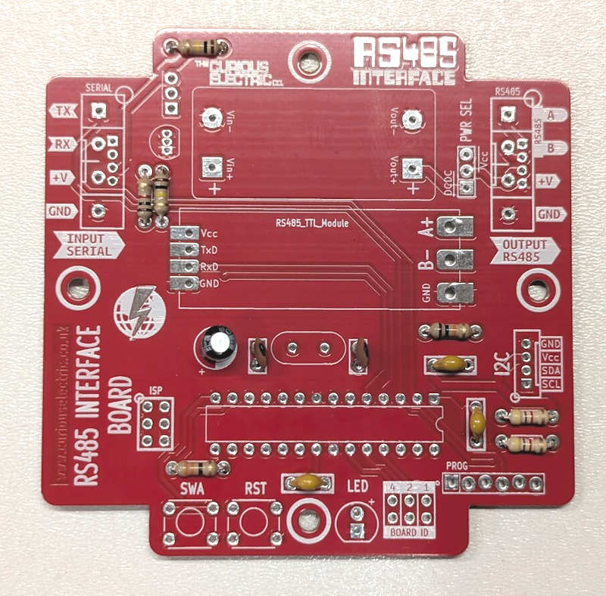 |  | First solder the non-polarised capacitors.  Orientation of these does not matter:  Next solder the polarised capacitor. Ensure correct orientation of this component.  The negative lead is marked with a white strip. The positive lead is slightly longer than the negative. Align the positive lead with the + sign and the negative lead with the white PCB marking.
  Value | Ref | Marking
  100nf | C1, C3, C4 | 104 (brown blob)
  22pf | C5, C6 | 22(orange disk)
  Value | Ref | Marking
  100uf | C2 | 16V 100uf

Step: 3 | Add IC holder and crystal
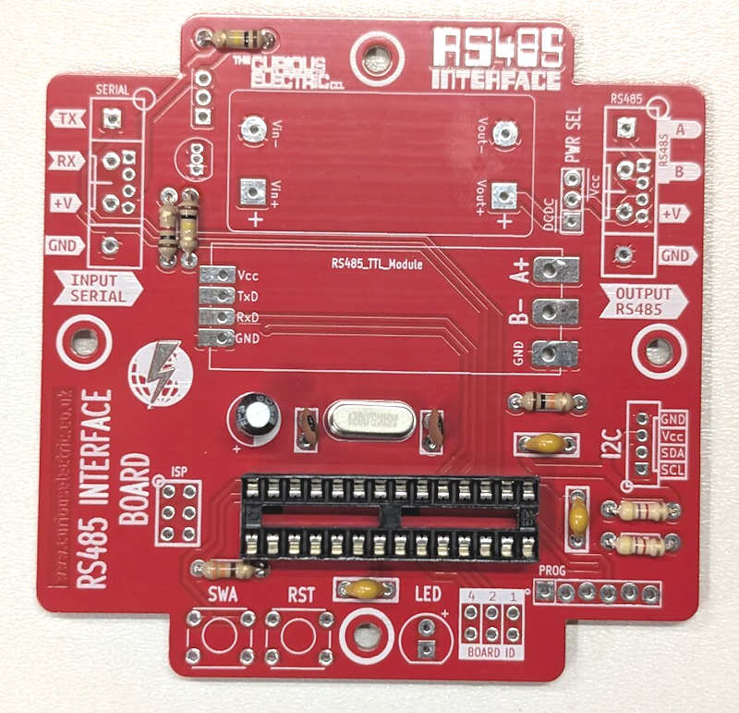 |  | A 28-pin IC holder fits into U2  Ensure correct orientation!  Ensure the notch on the holder aligns with the notch shown on the PCB.  The silver crystal is soldered into the area marked Y1. Orientation does not matter.

Step: 4 | Add Switches and LED
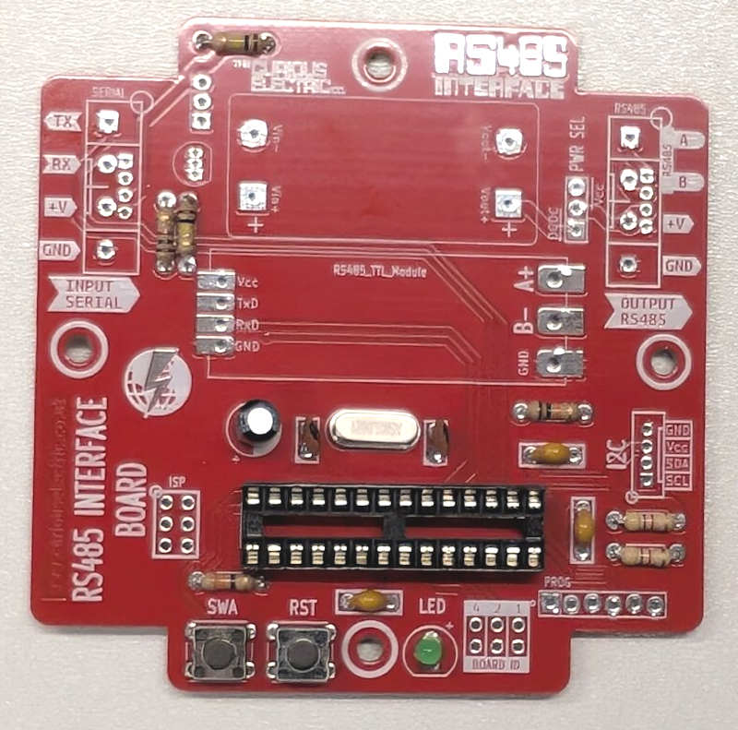 |  | Solder the two push switches into the areas marked SW1 (“SWA”) and SW2 (“RST”). They can only fit in the correct orientation.  Ensure correct orientation for the LED, D1.  Solder the LED into D1.  The long lead is positive, so place that into the hole marked +. The negative side is slightly flat.

Step: 5 | Add transistors
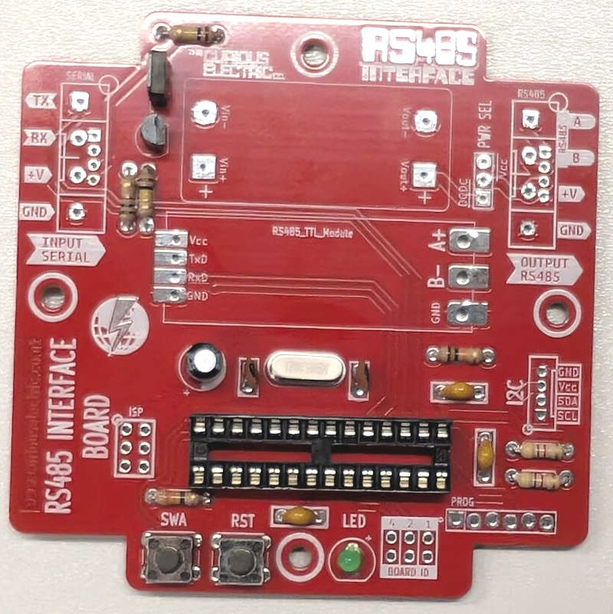 |  | Solder transistors Q1 and Q2 into the correct locations. Ensure both transistors follow the markings on the PCB.  There is a thicker white line showing which side the heat-sink on transistor Q2 should be aligned with.

Step: 6 | Add header pins and set ID
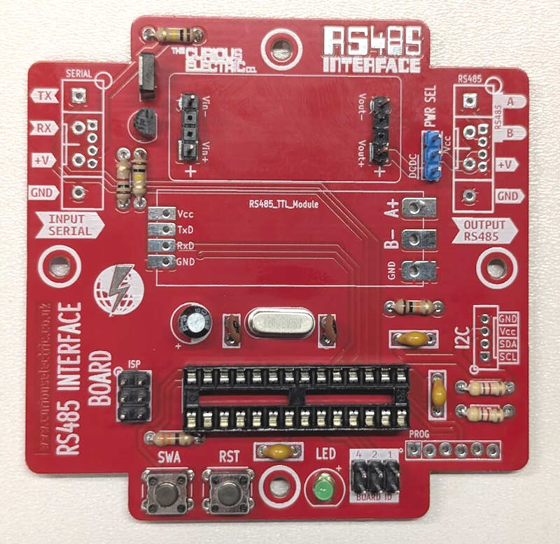 |  | Use the 2 x special 2 pin headers and solder onto the pads for the DC-DC converter (DCDC1)  Use the 3x1 header pins for the “PWR SEL” area (J1). A jumper on this controls if either the sensor is powered by the supplied voltage (on the input serial terminal) OR the DC-DC converter.  Use the 2 x 3x2 header pins and put them into the areas marked P7 and P9.  P9 is an ISP (In Series Programmer) connector for uploading code onto the unit (if needed)  P7 is used to set the board ID.  You can set the ID of the unit by connecting the header pads with a jumper. The default ID is 0, with no jumper attached.
  1 | 2 | 4 | ID
  NC | NC | NC | 0
  Jumper | NC | NC | 1
  NC | Jumper | NC | 2
  Jumper | Jumper | NC | 3
  NC | NC | Jumper | 4
  Jumper | NC | Jumper | 5
  NC | Jumper | Jumper | 6
  Jumper | Jumper | Jumper | 7

Step: 7 | Add RS485 module board
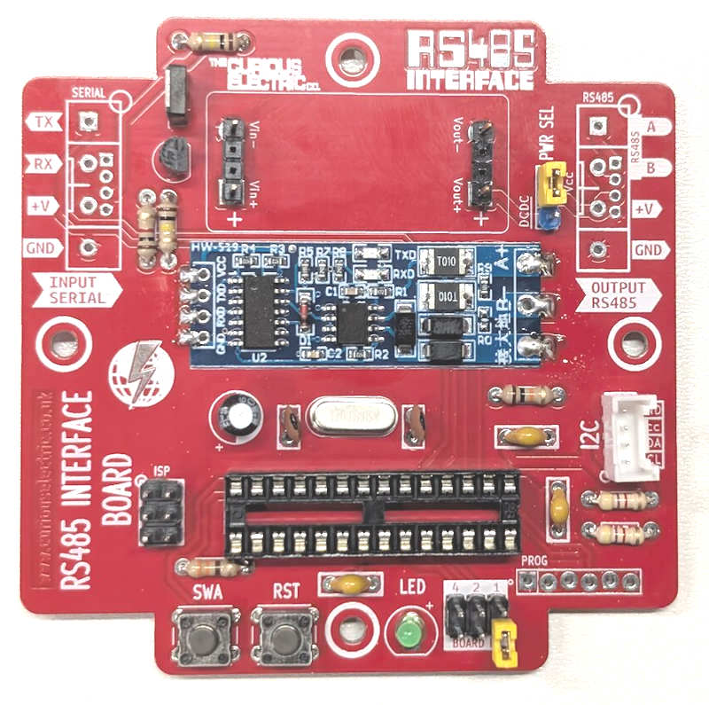 |  | Place the RS485-TTL module flat onto the circuit board. Ensure the pads align with the castellated holes on the module board.  Add a blob of solder to each of the pads (4 smaller ones on the TTL side and 3 larger ones on the RS485 side).  Ensure there is enough solder to make a good connection.

Step: 8 | Add DC-DC converter module
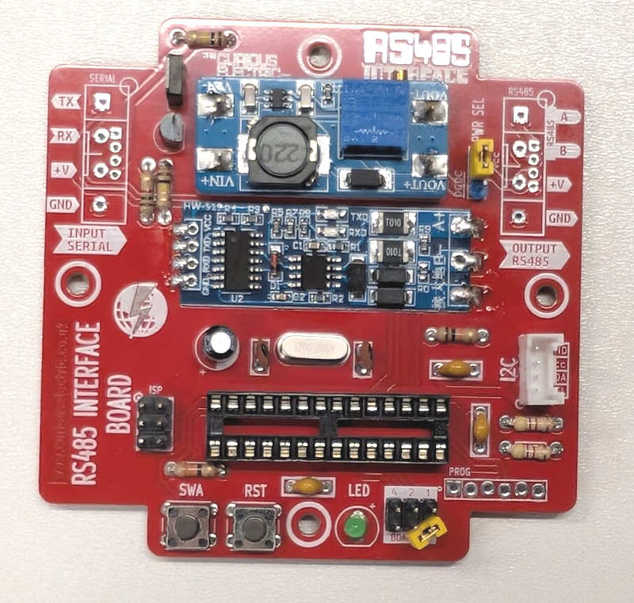 |  | Fit the DC-DC converter module onto the header pins you soldered in step 6.  Make sure this is put on the right way around. The flat side of the module should go against the main red PCB.  Make sure the little brass adjustment dial is pointing to the edge of the PCB.  This can be adjusted with a small flat screwdriver. It can be adjusted from 3.3V up to 30V DC. The max current is 2A, but it is advised to stay under 500mA at most.  Note: Before adding your sensor you must check the output voltage is correct for your RS485 sensor. See details later in these instructions.

Step: 9 | Add screw terminals and Grove connector
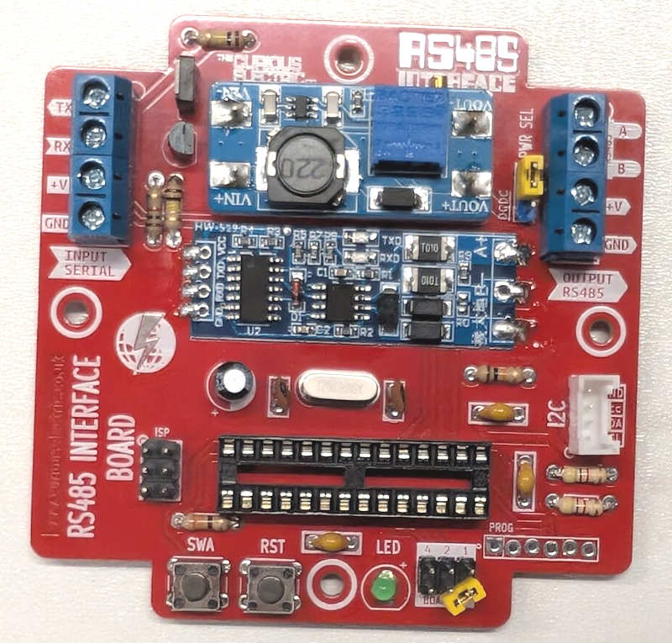 |  | Use two of the 2-way screw terminals and slot them together to make a 4 way screw terminal unit. Do this with the two sets of 2-way screw terminals.  Solder them into the areas for the INPUT (P1) and the RS485 OUTPUT (P6).  Ensure the holes for the cables are face out, so cables can enter from each side.  Also solder the ‘Grove’ 4 pin connector into P5. Ensure you fit this as shown, with the large notch facing to the edge of the PCB.

Step: 10 | Add microcontroller
You can now carefully insert the ATMEGA328 microcontroller into the IC holder.

Ensure the notch on the IC matches the IC holder and the PCB!
Be careful no pins are bent as you push this component in.

Step: 11 | PCB is finished!
Have a nice cup of tea.


Step: 12 | Check Device: Connect to USB-TTL Converter
To program and check the microcontroller then you will need a USB to TTL converter with the ‘FTDI’ pin out.  This fits into the ‘PROG’ connector.  This will also power the board.  You can also use a USB-TTL converter cable wired to the SERIAL INPUT terminals, but you will not be able to upload new code via that connector.  If you monitor the serial port at 9600 baud then you can send and receive responses.  Check that some data is being received and that the green light flashes to show the unit is working. |  | 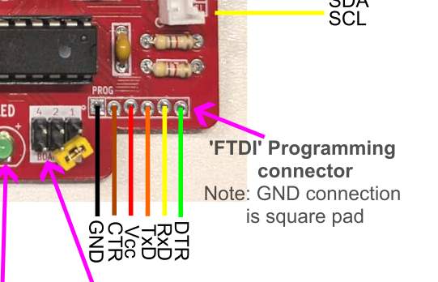  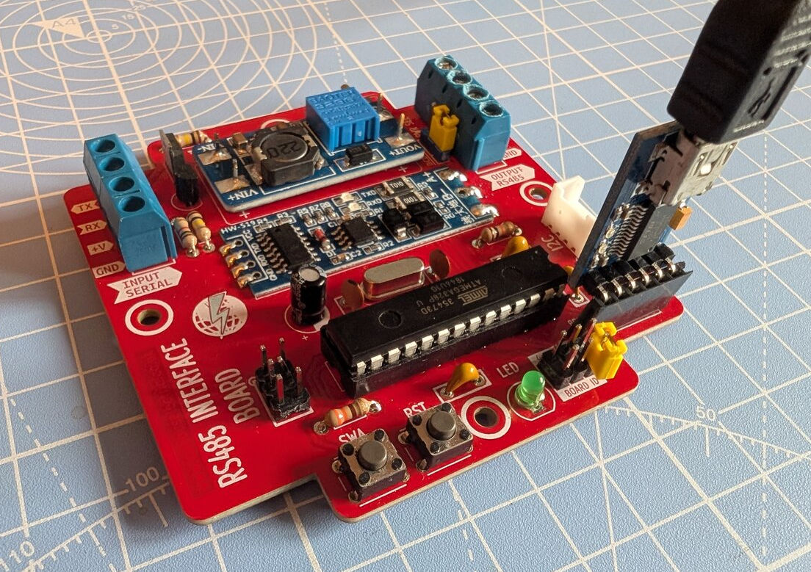

Step: 13 | Check DC-DC converter voltage
BEFORE you add the RS485 sensor test and double check the output voltage on the DC-DC converter.  Power up the device, either from the PROG connection OR from the “INPUT SERIAL” connections.  This will depend upon the ‘PWR SEL’ jumper, which chooses if the Serial Input +V voltage is used OR if the DC-DC converter is used.  If the DC-DC converter is used then check the output voltage with a multimeter. The voltage may jump as the power is switched, the higher voltage will be the ‘blip’ of output voltage for the sensor. This switches on and off to save energy.  This should be the same as required by your RS485 sensor.  Turn the little brass dial with a preset trimmer or small screwdriver. |  | 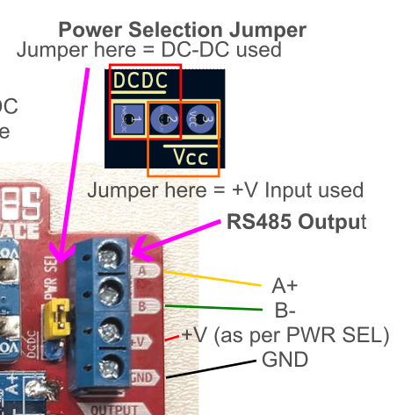  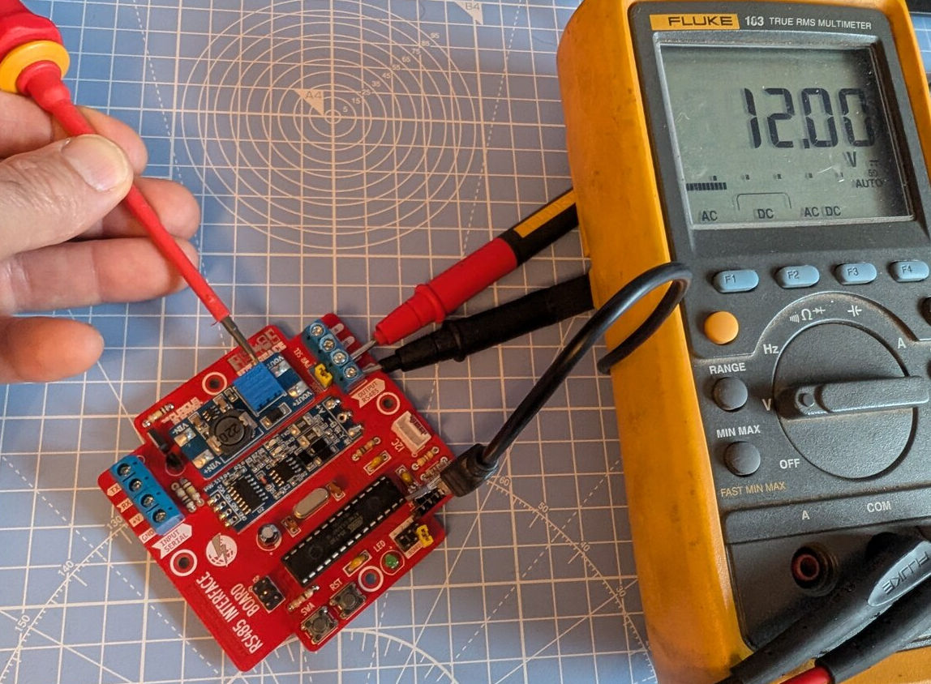

Step: 14 | Wire up RS485 Sensor
Now the output voltage has been set you can wire up the RS485 sensor you are using.  Switch off power to the board.  Wire up your sensor to the “OUTPUT RS485” terminals following the screen printed labels.  In the photo shown here, a solar pyranometer has been wired up.  Check your sensor data-sheet for the correct colour wires and pin out, as it may not be the same as shown here. |  | 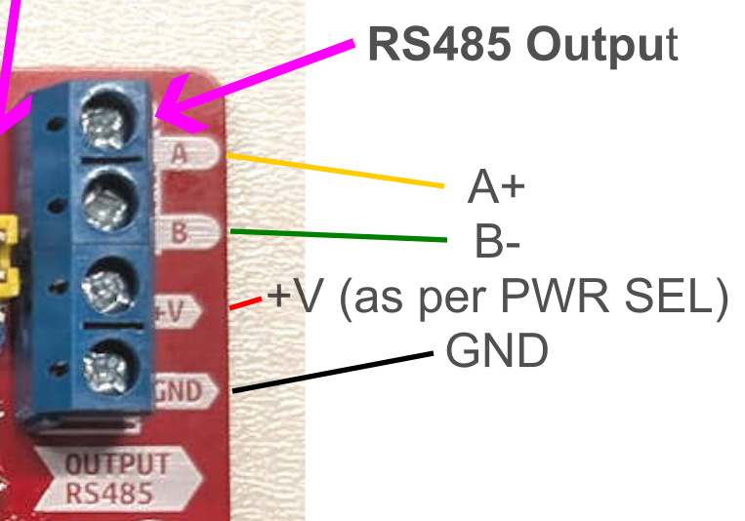  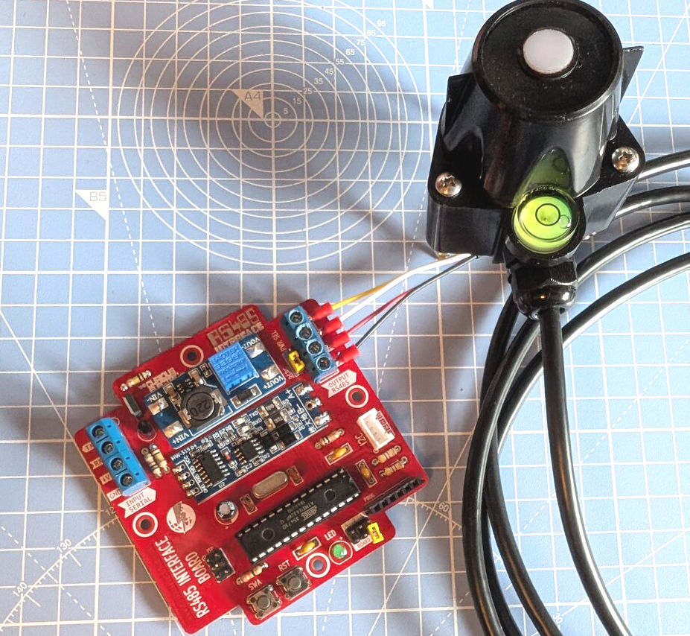

Step: 15 | Wire up the Serial Input to your microcontroller.
There is one main ‘Input Serial’ connector (sometimes called UART Input).  Wire this up to your microcontroller or to a USB-TTL converter cable.  Double check that Rx and Tx are correctly wired (usually Rx from the microcontroller goes to Tx of the sensor and vice-versa).  Check you are getting data via the Input Serial connections. |  | 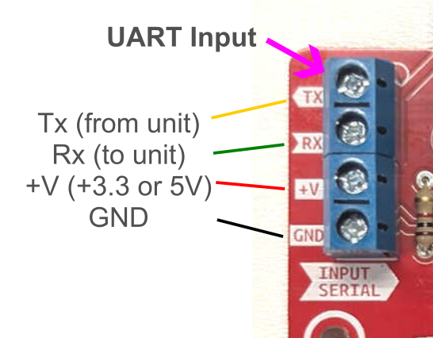

Step: 16 | Program Device: Connect to USB-TTL Converter
Note: This step is only needed if firmware not already uploaded.

To program the microcontroller then you will need a USB to TTL converter with the ‘FTDI’ pin out.

If you monitor the serial port at 9600 baud then you can send and receive responses. You can also upload new firmware using the Arduino IDE.

These units use the ‘MiniCore’ board manager and the IC is the “ATMEGA328” with an “External 16MHz” oscillator.

Follow the github examples and information for the most up to date information regarding the serial data and the functionality of the unit.

Step: 17 | Ensure the firmware used on the unit is the correct version for your sensor!
Different firmware options are required for different RS485 sensors.

This can be where the fun begins! You can alter the code and improve it as you need.

Note: This step is only needed if the correct firmware has not already been uploaded.

For options and firmware upload options, please see:

https://github.com/curiouselectric/SensorInterfaceBoard

This is kept online, so it can be easily updated.

Step: 18 | Send Serial Commands
There are many serial commands that the unit can respond to.

In normal operation the unit will start up and the LED will flash every 5 seconds to show it is alive.

If you monitor the serial port data you should see data at 1 or 10 second intervals at 9600 baud rate. This depends upon the send rate selected. Press SWA and this will roll through the 6 data send rates (which are 1second, 10 second, 60 second, 10 min, 1 hour and “no data send”). Put it into 1 second data mode and you should see data appearing every second. Check the data looks correct.

For the most recent information, please see:
https://github.com/curiouselectric/SensorInterfaceBoard

This is kept online, so it can be easily updated.

Step: 19 | Write your own code
Everyone’s application is different, so this is where things get fun for your application!

You need to think about what you would like from the unit.

I have set up units that send out data at regular 1 min outputs with a wireless transmitter. This used broadcast mode.

I have also set up units that record the data to an SD card by using request mode.

Contact details:
This kit has been designed and produced by:

The Curious Electric Company
hello@curiouselectric.co.uk
www.curiouselectric.co.uk

We would like you to be happy with this kit. If you are not happy for any reason, then please contact us and we will help to sort it out.

Please email hello@curiouselectric.co.uk with any questions or comments.
Please tweet us at @curiouselectric

If any parts are missing from your kit, then please email hello@curiouselectric.co.uk with details, including when and where the kit was purchased.

More technical information can be found via www.curiouselectric.co.uk

Circuit Schematic Page 1:

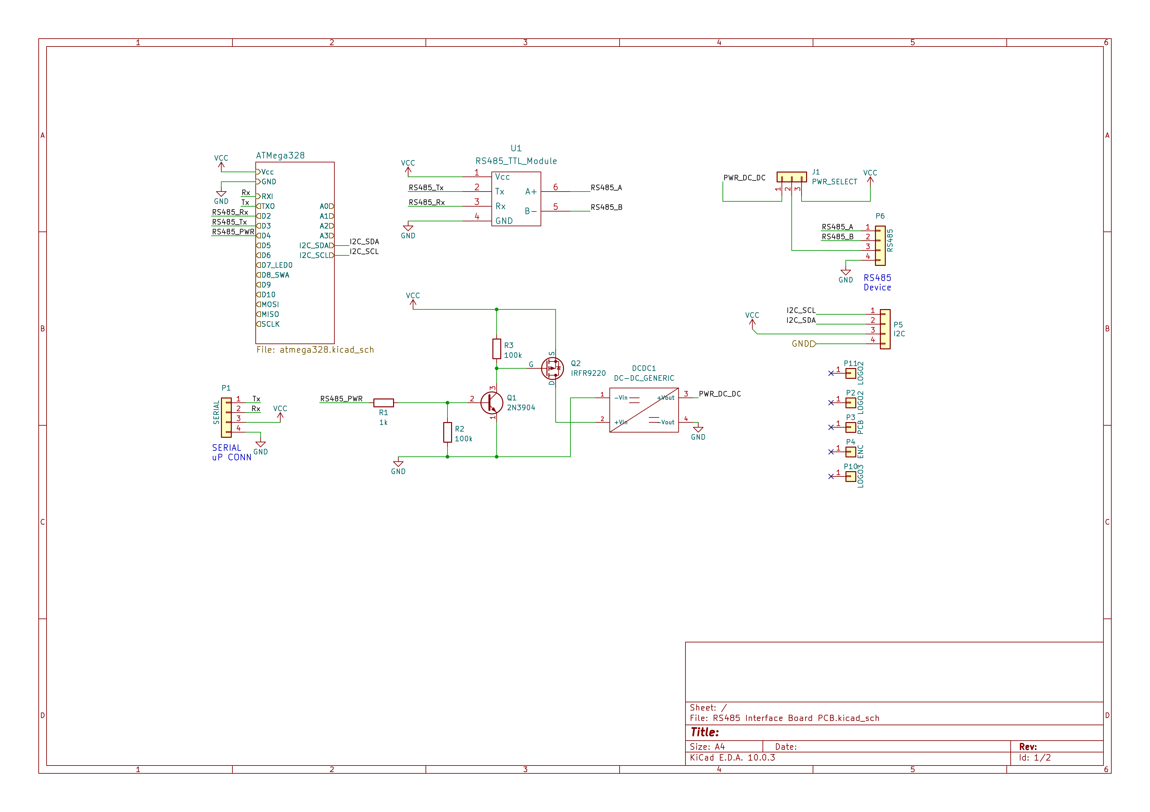

Circuit Schematic Page 2:
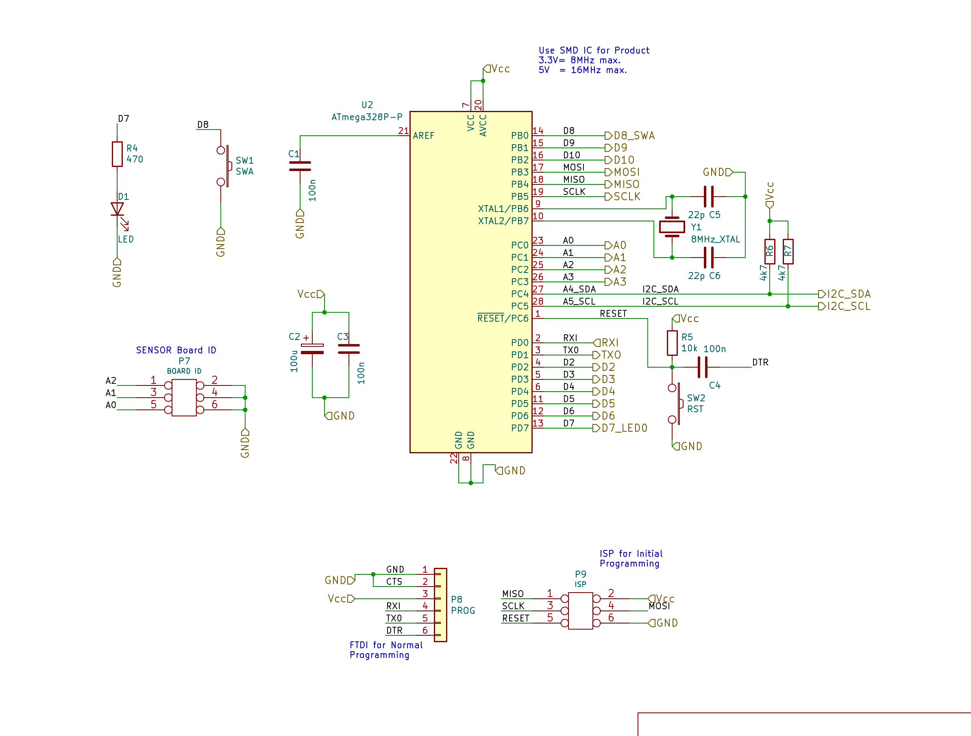

PCB Design:

